# Graphic Design Documentation

## The Pirates: Candy Hunt

Start of project: July 16, 2019

Logo: The pirates: Candy Hunt

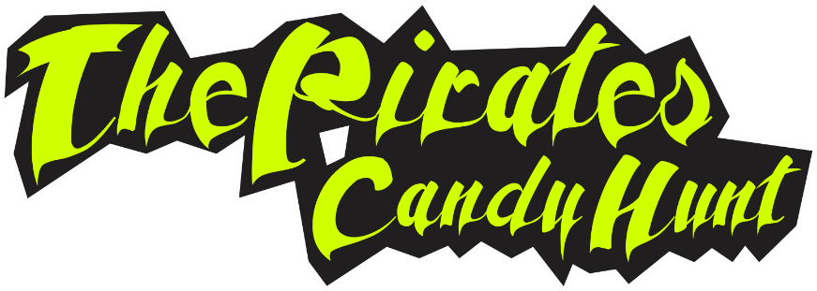

Arm: The pirates: Candy Hunt

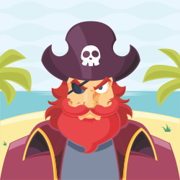

## Version: 1.0.6

### GDD “ The Pirates: Candy Hunt ” Written by: Sadeq Soltani

a game production by



# Design History

## Version 1.0.0

July 16, 2019 to Aug 01, 2019

Version 1.0.0 is the creation of this game design documentation (GDD). The basic framework of the documentation is created so that more information can be included more efficiently, with each section labeled. The content page is created as well.

## Version 1.0.1

Aug 11, 2019

Version 1.0.1 is the updated version of the design document with the following segments filled-in: the Game Overview, the Story and the Core Game Mechanics. A new segment is added in; the Core Game Sequence which outlines the typical flow of the game so that visualization is easier. Basic attributes are added to serve as a rough guideline.

## Version 1.0.2

Aug 23, 2019

Version 1.0.2 includes the updates of some of the core game mechanics as well as in the inclusion of the interface flowchart. The story and game overview is also updated.

## Version 1.0.3

Aug 31, 2019

Version 1.0.3 contains the updated Appendix with the pre‐conception and conception visual works. The Character section is also filled in with descriptions and the concept art. Minor updates to the Core Game Mechanics.

## Version 1.0.4

Sep 19, 2019

Version 1.0.4 includes the updated version of the Core Game Mechanics with some minor amendments made, as well as the update of the “Objects list” with the attributes of the objects stated. Updated interface flowchart to include Achievements, as well as Core Game Mechanics.

## Version 1.0.5

Oct 07, 2019

Version 1.0.5 includes the update of the game overview with the resolution size edited.

## Version 1.0.6

Oct 17, 2019

Version 1.0.6 is a major update because of the change of the theme, style and game play of the game. The Game Overview, Story and Core Game Mechanics are all edited to address the new game design. More mechanics are added and some removed. The interface flowchart as well as mock out are updated and included in this revision of the documentation.

## Version 1.0.7

Oct 30, 2019

Version 1.0.7 contains the updates of the Core Mechanics, which includes the score mechanism, and some minor additions to firm up the concept of the design. The Objects section is updated with the new list of objects, though not fully complete. Attributes are assigned to the objects as well. The plot points of the story are changed to the updated one as well.

# Overview

## Theme / Genre

* 1 - Pirate Theme
* 2 - Action-Adventure

## Features

* 1 - 2D game
* 2 - Arcade-Game
* 3 - Single Player
* 4 - Fixed Camera view
* 5 - Dynamic music and feedback
* 6 - Visual Feedback

## Targeted platforms

* 1 - Android Platform
* 2 - IOS Platform

## Intended Audience

The intended audience of this game is primarily for both genders from the age range of 3 years of age and above. The language of the game is contains so many catchphrases from pirates but they were hand-picked to be proper for any age and therefore, the audience could be 3 years of age or above.

## Language

* 1 - English
* 2 – Persian

*There is no aggressive, dirty, or inappropriate language is used in this game.

## Sound Consideration

The game play experience of this game depends very much on the music. In this game, we will be including sounds such as the main music for the levels, sound scaping, audio feedbacks, cutscene sounds, and interface and in‐game sound effects.

## What sets this project apart?

* Reason #1
* Reason #2
* Reason #3
* Reason #4
* Reason #5

## Project Scope

Project Time Scale

Every game have a deadline for presentation. So when this journey began at

Jul. 16, 2019 . We believed that we will ready to present at “ Dec 1st , 2019 “

and today is “ Oct 31st , 2019 “ At the Version 1.0.7 , We hope to bring this game to life by the time .

**Team Size**

**Core Team**

* Project Manager / Name? / Salary?
* Graphic Designer / Name? / Salary?
* Programmer / Name? / Salary?
* Animator / Name? / Salary?
* Sound & Music / Name? / Salary?

**Marketing Team**

* Head of Marketing / Name? / Salary?
* Marketing Personal / Name? / Salary?

Licenses

* License 1 / Source1 / Cost $
* License 2/ Source2 / Cost $

Hardware

* License 1 / Source1 / Cost $
* License 2/ Source2 / Cost $

Other Cost

* Coffee / Source1 / Cost $
* Tutorials / Source2 / Cost $

## Total Costs With Breakdown

* **Cost $**

## The elevator Pitch

Pretend that your were pitching your game to a executive going to the elevator. You have less than 60 Seconds.

# Gameplay

## Gameplay (Brief)

<The Summary version of below>

## Gameplay (Detailed)

<Go into as much detail as needs be>

<Spare no detail>

<Combine this with the game mechanics section above>

# Story

Outline

The story revolves around Pirate life, the adventurous vision in the late 17 century, The golden age of piracy, this is about a young sailor who decide to take down all of mean pirates one by one and own their ships and own their life-style. This is a story of a young sailor who wants to help others by becoming a pirate.

And there is twist in story that you must collect “ Candy “ as much as you can and share it with others.

Story Synopsis

One young sailor is going to take down all of mean pirates one by one and take all their Ships, Coins and Candies in order to can defeat strongest pirate in the whole seas “ The Black Beard “ . In order to defeat him, you must defeat more pirates and take their fleet . after take down 11 pirates you can take down “ The Black Beard “ for good, and remember that you must be a different pirate and share all of your coins and candies with others.

# Core Gameplay Mechanics (Detailed)

## Core Gameplay Mechanic #1 – Camera

There will be a fixed camera . The camera does not move at all throughout the game.

## Core Gameplay Mechanic #2 – Single Player

In this game, the player controls the main ship . This game is meant for a single player playing experience.

## Core Gameplay Mechanic #3 – General Movement

The player may choose to move within the game. if the player does not move the ship, the ship will remain still and exposed to NPC(Enemy) for attack . To move Left or Right, the player has to either hit the ← or → key, which moves the ship Left or right and To move Up or Down, the player has to either hit the ← or → key, which moves the ship Up or Down. Refer to the Control Summary below for a more detailed listing of the control scheme.

## Core Gameplay Mechanic #4 – Initial Setup

The Ship is going to spawn at starts at the bottom of screen and the NPC is being spawn at starts at the top of screen. Depending on the difficulty level as you’ll see in the table in the stage difficulty section, the speed, health and fire rate of the ship is different, the amount of objects are varies. Depending on the stage, child ships might be spawned as well.

## Core Gameplay Mechanic #6 – Health

The ship has a health bar which decreases when he hits Junk candies, enemy ships, canon balls. When the health bar reaches zero, the Ship will be destroy, and the game ends. In this game, health can be replenished. The following table shows how health is deducted when the ships hits the respective objects:

## Core Gameplay Mechanic #7 – Low / Critical Health

When the ship’s health reach 75% and below, health bar icon will be a little brighter than 100% and the sound of heart beats is played and When the ship’s health reach 50% and below, health bar icon will be a little brighter than before and the sound of heart beats is played faster and When the ship’s health reach 25% and below, health bar icon will be a little brighter than before and the sound of heart beats is played even faster. This signals to the player that the ship is in low health. to signify to the player that the health has reached a critical stage. The ship will be destroy when its health reaches 0% and Win / Game over panel will be displayed.

## Core Gameplay Mechanic #8– Moving Objects

There are 3 kinds of objects that will move within the game.

They are namely the:

1. Candy

→ Collect in order to accomplish “ Score ” for exchanging with the “ Keys “.

2. Coin

→ Collect in order to accomplish “ Coins ” for exchanging with the “ Ships “.

3. Magic Candy

→ Collect in order to Gain an special “ Power ” for certain amount of time.

4. Junk Candy

→ DON’T Collect these to Stay safe and continue to avoid them at any time.

## Core Gameplay Mechanic #9 – Magic Candy

2X Sized Ship & 2X Faster Balls

When the ship has collision with this magic candy the ship size will be twice before and the canon ball’s speed will be twice faster for 15 second and the sound of Magic candy will be played.

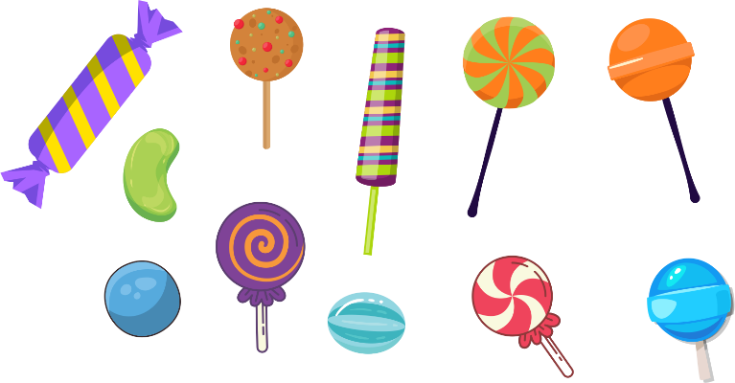

4X Canon Ball’s Power

When the ship has collision with this magic candy the canon ball’s power will be 4 times more power full for 15 second and the sound of Magic candy will be played.

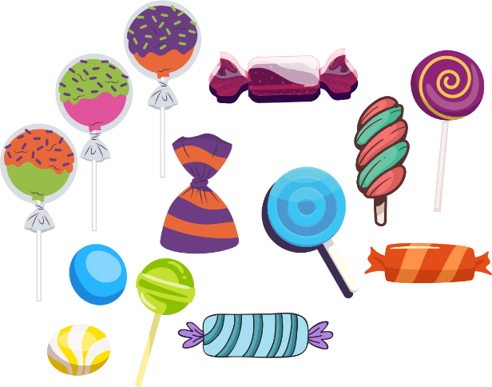

2X Fire Rate

When the ship has collision with this magic candy the canon’s Fire Rate will be twice faster (you shoot faster) for 15 second and the sound of Magic candy will be played.

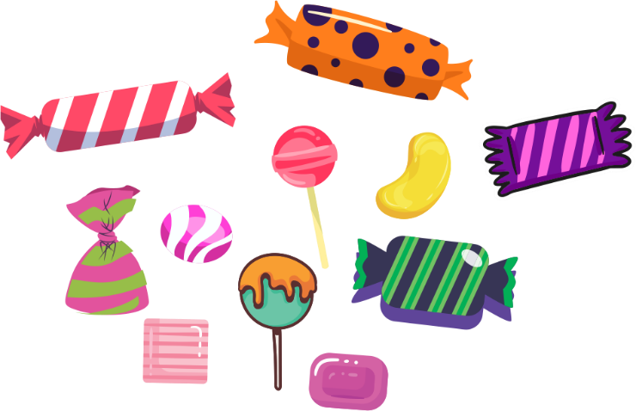

Magnet

When the ship has collision with this magic candy the ship a big magnet will show up and it will bring all of Coins to the ship without moving toward them for 15 second and the sound of Magic candy will be played.

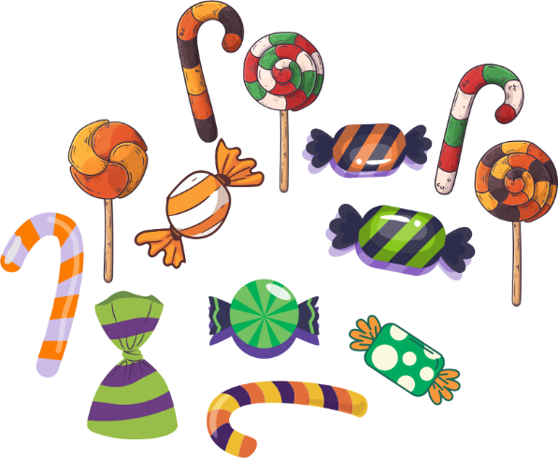

Plus Canon Balls

When the ship has collision with this magic candy the ship the canon ball’s number will be twice and the sound of Magic candy will be played.

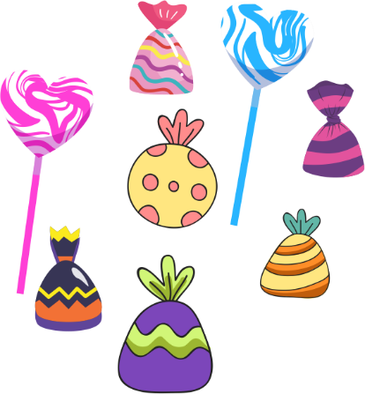

Plus Health

When the ship has collision with this magic candy, the player’s health will be twice before and the sound of Magic candy will be played.

*Health bar can NOT be more than was at the start.

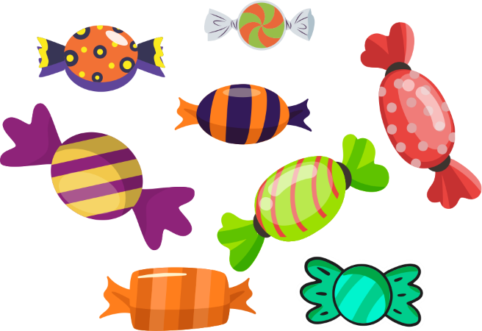

Shield

When the ship has collision with this magic candy a shield will show up around the ship and nothing could hurt the ship for 15 second and the sound of Magic candy will be played.

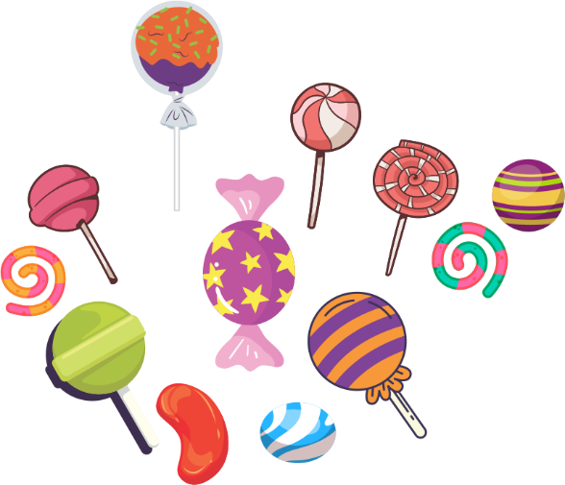

## Core Gameplay Mechanic #10 – Junk Candy

2X Child Ship

When the ship has collision with this Junk candy, 2 child ship will be spawn at the top of screen and if you don’t destroy them, they will be spawn again at the top of screen and the sound of Junk candy will be played.

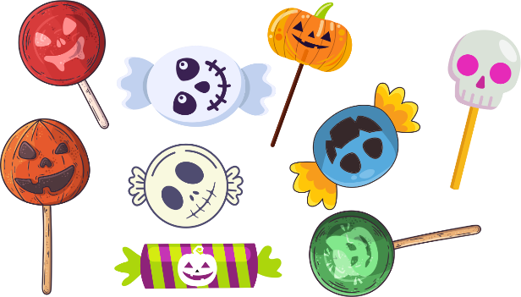

4X Times Junk Spawner

When the ship has collision with this Junk candy, 4 Junk Spawner will be spawn at the top of screen and spawn more junk candy for 15 second and the sound of Junk candy will be played.

*there is only 1 junk spawner at the start.

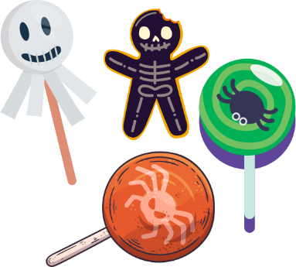

Minus Canon Ball

When the ship has collision with this Junk candy the ship the canon ball’s number will be minus “ half ” of it and the sound of Junk candy will be played.

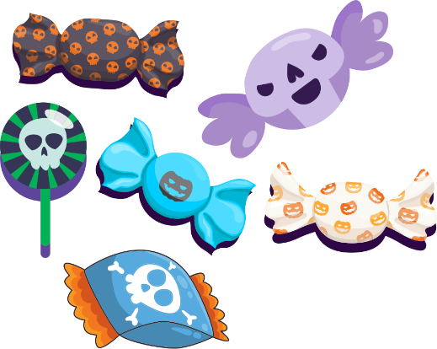

Minus Health

When the ship has collision with this Junk candy, the player’s health will be minus “ half ” and the sound of Junk candy will be played.

*Health bar can NOT be less than was at the start.

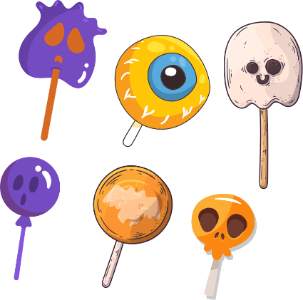

No Shot

When the ship has collision with this Junk candy, the ship can NOT shoot canon balls for 15 second and the sound of Junk candy will be played.

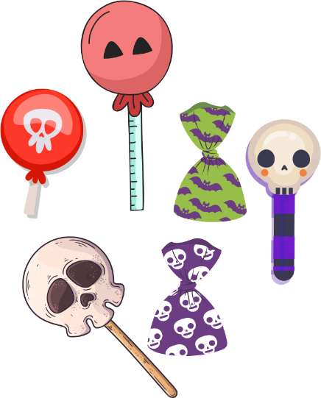

Super Size Ship

When the ship has collision with this Junk candy, the ship will be too big to dodge the enemy’s balls for 15 second and the sound of Junk candy will be played.

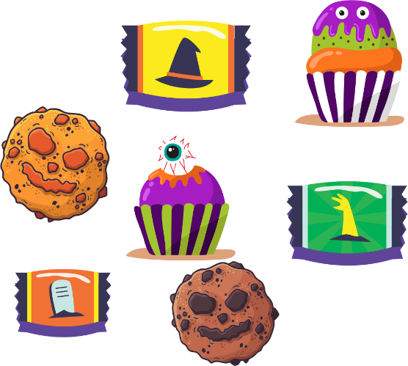

2X Enemy Ship

When the ship has collision with this Junk candy, 2 Enemy ship will be spawn at the top of screen and if you don’t destroy them, they will be spawn again at the top of screen and the sound of Junk candy will be played.

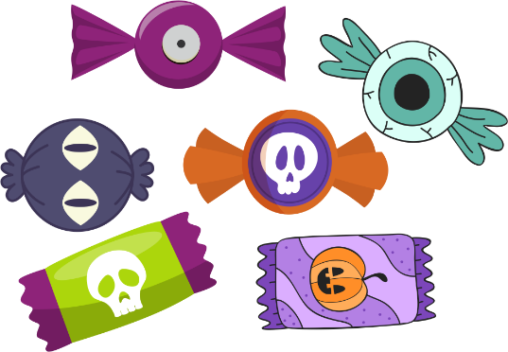

## Core Gameplay Mechanic #11 – Collision Between Objects

Player Canon ball with Enemy Canon ball

When the player’s ball hits the enemy’s ball, both will explode and the sound of explosion will be played.

Player Canon ball with Enemy Ship

When the player’s “ ball “ hits the enemy’s “ Ship “, the ball will explode and depend on the ball’s type, impact going to be different and the sound of explosion will be played.

Example:

Ball type #1 = 1 /// Enemy ship’s power = 5 ////////////// Enemy ship’s power - Ball type #1 = 4

Ball type #2 = 2 /// Enemy ship’s power = 5 ////////////// Enemy ship’s power - Ball type #2 = 3

Ball type #3 = 5 /// Enemy ship’s power = 5 ////////////// Enemy ship’s power - Ball type #3 = (0) Destroyed

Player Canon ball with Candy, Junk Candy, Magic Candy

When the player’s “ ball “ hits the Candy, Junk Candy, Magic Candy,

the ball will explode and depend on the ball’s type, impact going to be different and the sound of explosion will be played.

The Player with Enemy Ship

When the player’s “ Ship “ hits the enemy’s “ Ship “ or the other way around, the one with less power will explode and the one that survives will be deducted its power exactly the amount of power that the other ship had, and the sound of explosion will be played.

Example:

Player’s power = 3 /// Enemy’s power = 5 ////////////// Enemy’s power - Player’s power = 2

Player’s power = 4 /// Enemy’s power = 5 ////////////// Enemy’s power - Player’s power = 1

Player’s power = 6 /// Enemy’s power = 5 ////////////// Enemy’s power - Player’s power = (-1) Destroyed

The Player with Candy, Junk Candy, Magic Candy

When the player hits the Candy, Junk Candy, Magic Candy,

They’re going to destroy and depend on the Candy type, impact going to be different and the sound will be played.

The Player with Enemy Canon ball

When the character’s health reach 25% and below, a pulsing red border appears around the screen and the sound of heart beats is played.

## Core Gameplay Mechanic #12 – Deactivating Objects

Crossed Objects

There is 4 deactivator one at the top, out of screen and one at the bottom, right and left to deactivate Crossed objects that going out of screen in any direction. This system also helping us to find out how many balls, Enemy or child ships , coins, magic candy, junk candy, candy and other things are being crossed and player missed.

## Core Gameplay Mechanic #13 – Scoring System

Scores

Scoring system will be on Destroying “ junk ” and “ enemy ships ” , and also collecting “ Candy “. Of course you can exchange your score for

“ key ” and keys going to help you unlock stages and by second chances to continue playing at the end of levels.

Keys

Key system will be on winning and playing more, the more players win, more keys will be owned. Player can collect key by winning a level, every level depends on its difficulty, has different amount of keys to offer. You can also exchange “ Key “ with “ Scores “.

This system is exclusively designed to unlock stages, ships , others.

Coins

Coin system will be on collecting only in this game, you can NOT exchange anything in-game to get more coin. Coins are exclusively designed to buy “ ship “ only. Of course, you can buy coin in the shop in order to buy better ships.

* + There is no grading system, for simplicity of game.

## Core Gameplay Mechanic #14 –Status Trigger

**Communication Triggers**

When the player does something wrong, the game will communicate failure to the player by having a side character pop out from either one of the bottom two corners of the game screen. The side character will display visual and audio feedbacks to the player in terms of failure, either positive or negative ones depending on the state.

Win / Game Over Screen Statistics

When the player wins / loses a level, they will be brought to a Win / Game Over screen. If the player wins in any level, they will be brought to the same winning screen but there is a bonus screen that it comes before winning screen and it has different number depend on the level that player wins, but If the player loses, the player will be brought to the same losing screen no matter which level players in . The following is a list of statistics to be displayed on the screen in the Win / Game Over screen.

Interface Flowchart

This is an expanded flowchart from the main game play screen to the end of level 3, showing the in between screens that are missed in the previous one.

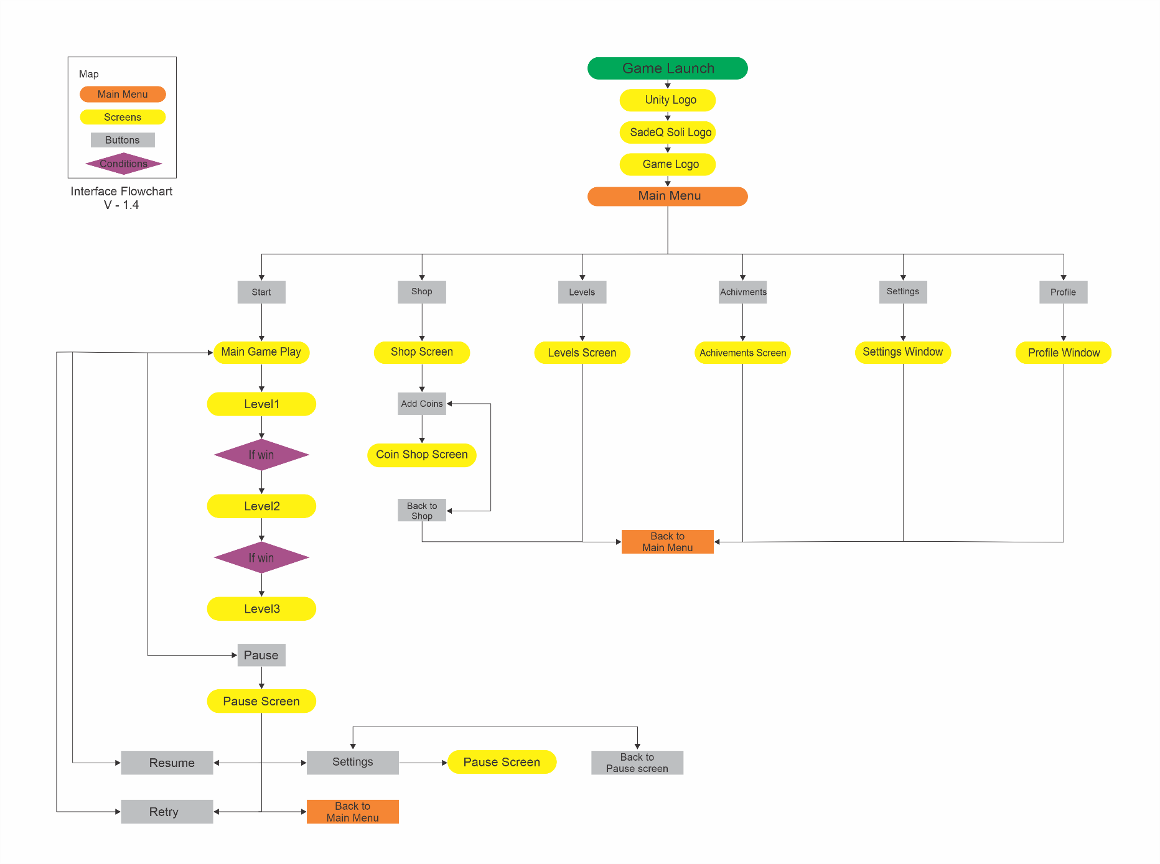

In-Game Elements

This screenshot shows the elements that the interface essentially has.

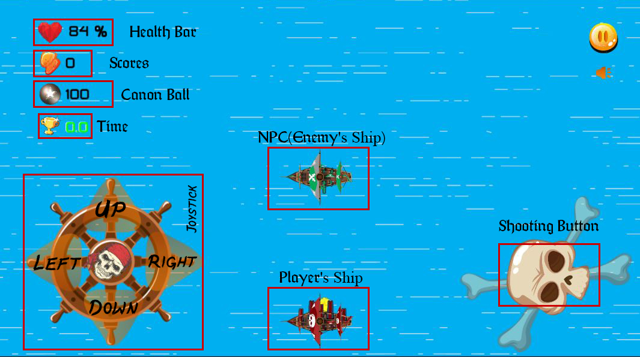

**Game Screen**

→ Where all the game play takes place in.

**Character**

→ The player’s ship.

→ The enemy’s ship.

**Ship’s Rodd (Joystick)**

→ For moving the ship to any direction.

**Cross bone and Skull (Shooting)**

→ Skull Rotates all the time and its for shooting.

**Pause Button**

→ Pause button at the top/right of screen to show up pause panel.

**Mute Button**

→ For muting all of sounds and music at once in the gameplay.

**Health Bar**

→  Shows how much health the player (ship) has left.

**Score Bar**

→  Shows how much score the player (ship) has collected.

**Canon Ball Bar**

→  Shows how much canon ball the player (ship) has left.

**Time Bar**

→  Shows how much time the player (ship) has left to win.

**Subtitle**

→ Enforces what the NPC (Enemy) said.

**Junk Candy**

→ player should avoid it to stay safe.

**Magic Candy**

→ player should collect these to get more powerful.

The Player & The Enemy

To define player from enemy you should know that player always will be spawn at the bottom of screen and its canons are faced up and the enemy is exactly opposite of player direction and position.

Example:

Characters

**The Player => Captain <Username>**

→ This is the character that going to conquer the pirates and their fleet.

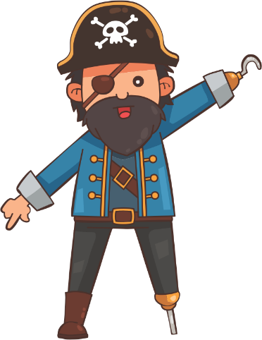

**The Enemy#1 => Captain Francis Spriggs (Dragon of the Sea)**

→ This is the character that going to conquer the pirates and their fleet.

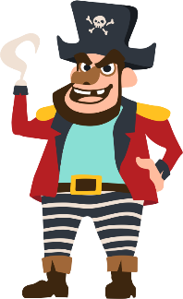

**The Enemy#2 => Captain Edward Low (Ned Low)**

→ This is the character that going to conquer the pirates and their fleet.

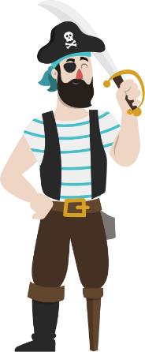

**The Enemy#3 => Captain Anne Bonny (Pirate Queen)**

→ This is the character that going to conquer the pirates and their fleet.

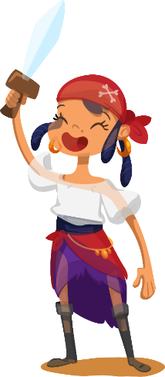

**The Enemy#4 => Captain Cheung Po Tsia (Black Swan)**

→ This is the character that going to conquer the pirates and their fleet.

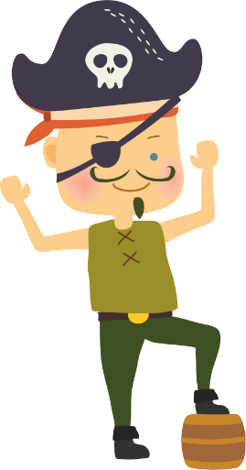

**The Enemy#5 => Captain George Lowther (The Dragon)**

→ This is the character that going to conquer the pirates and their fleet.

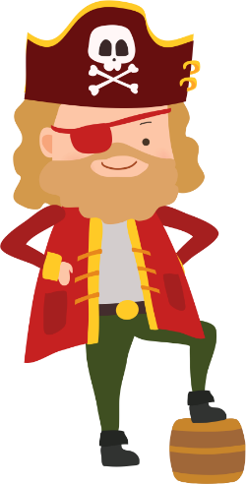

**The Enemy#6 => Captain Calico (Pirate King)**

→ This is the character that going to conquer the pirates and their fleet.

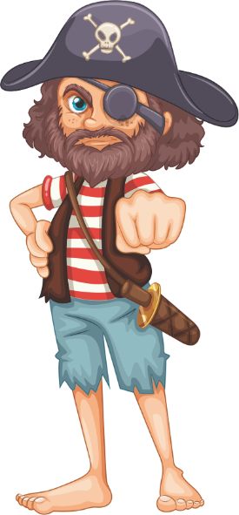

**The Enemy#7 => Captain Bartholomew Roberts (Black Bart)**

→ This is the character that going to conquer the pirates and their fleet.

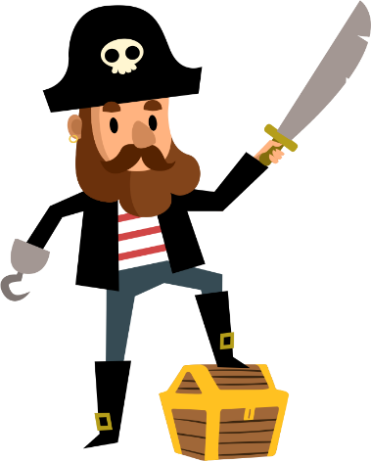

**The Enemy#8 => Captain Stede Bonnet (The Gentleman)**

→ This is the character that going to conquer the pirates and their fleet.

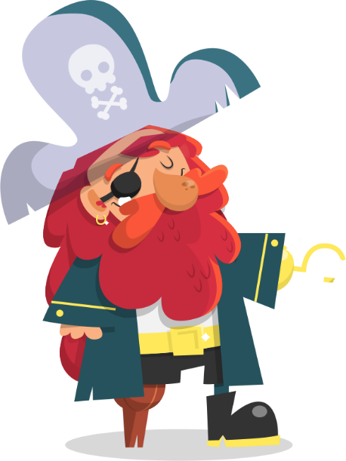

**The Enemy#9 => Captain Caesar (The Black Caesar)**

→ This is the character that going to conquer the pirates and their fleet.

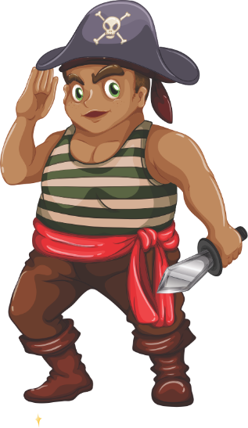

**The Enemy#10 => Captain Francis Drake (The Hunter)**

→ This is the character that going to conquer the pirates and their fleet.

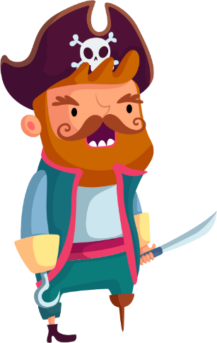

**The Enemy#11 => Captain Charles Vane (The Savage)**

→ This is the character that going to conquer the pirates and their fleet.

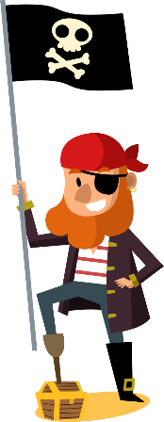

**The Enemy#12 => Captain Calico Jack (Red Jack)**

→ This is the character that going to conquer the pirates and their fleet.

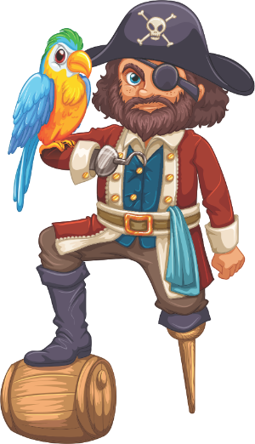

**The Enemy#13 => Captain Edward Teach (The Black Beard)**

→ This is the character that going to conquer the pirates and their fleet.

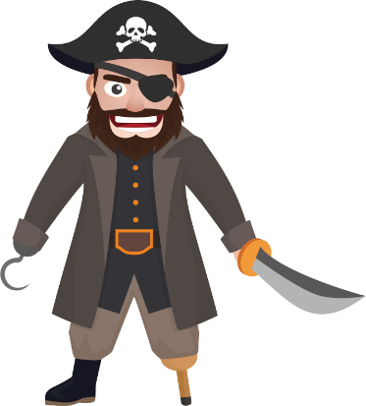

The Stage Difficulty

So to understand the stage system of this game, we should know every stage is a war against on of the evil pirates and every stage has 24 levels. That means every level is a battle to win the war. So to win “ the great war ” player should win every battle and every war against these evil pirates. There are 288 levels divided by 12 stage of 24 level. (12 * 24 = 288)

For example:

